Deep Learning–Based Classification

1. Model Architecture and Training Procedure
A convolutional neural network based on ResNet-18 was employed to classify environmental states from Range–Doppler (RD) feature maps generated from Wi-Fi CSI. Each RD map was treated as a single-channel grayscale image and replicated to three channels to match the ResNet input requirements. The final fully connected layer was modified to output three classes: Active, Calm, and Chaotic.
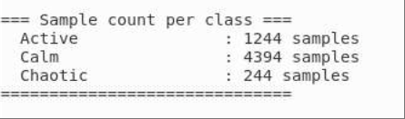
The model was trained from scratch (no pre-trained weights) using the AdamW optimizer with a learning rate of $1×{10}^{-3}$, weight decay of $1×{10}^{-4}$, batch size of 32, and a total of 64 epochs. The loss function was cross-entropy, and model performance was monitored using macro-averaged F1-score, accuracy, and validation loss. The dataset was split into 70% training, 15% validation, and 15% testing sets.

2. Training and Validation Behavior
Figure 1 shows the training curves for loss, accuracy, and macro-F1 across epochs.
- The training loss steadily decreased to near zero, while the validation loss increased after approximately 15 epochs, indicating a degree of overfitting.
- The training accuracy and F1 reached nearly 100%, but validation accuracy stabilized around 75–80%, with macro-F1 fluctuating between 0.55–0.60, showing that the model captures meaningful but partially overfitted patterns.
- Early stopping or regularization (e.g., dropout, data augmentation) could further improve generalization.
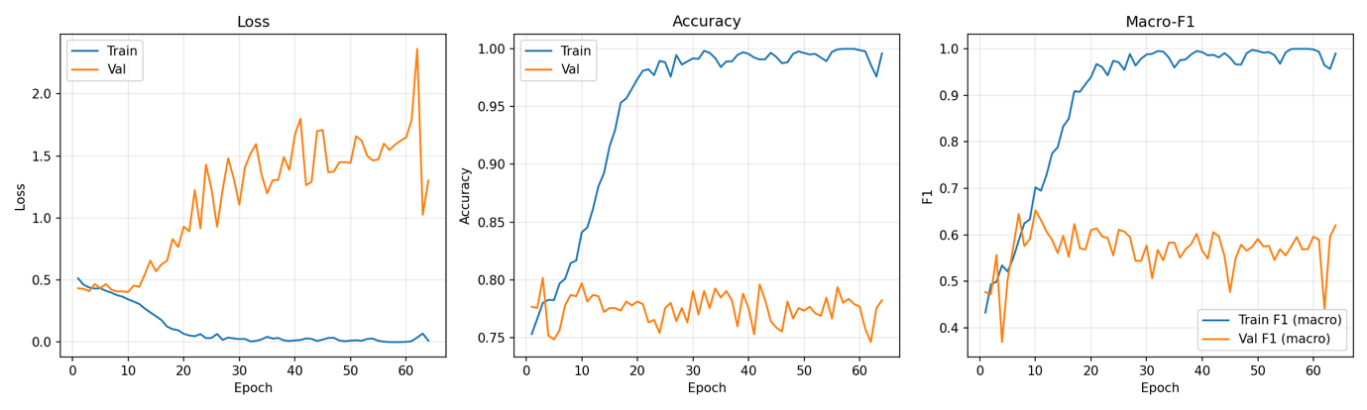

3. Confusion Matrix Analysis
Figures 2 and 3 show the confusion matrices (raw counts and normalized). The diagonal elements represent correctly classified samples.
- The model performed best on the Calm class, achieving an 81% true positive rate, as this class dominates the dataset and exhibits relatively consistent Doppler–Range patterns.
- The Active class achieved moderate accuracy (≈65%) but often confused with Calm due to similar low-Doppler characteristics when motion is subtle.
- The Chaotic class was the hardest to recognize (≈43%), as its range–Doppler signatures overlap with Active in frequency-domain variation.
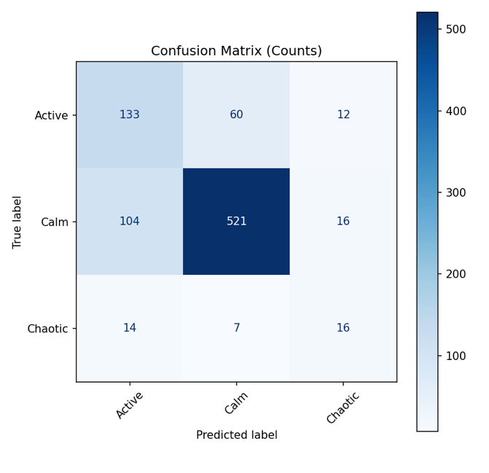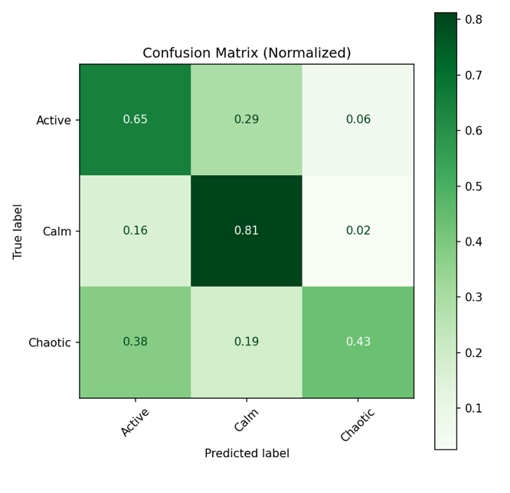

4. Quantitative Results
The detailed classification metrics on the test set are listed in Table 1.
The model achieved an overall accuracy of 75.9% and a macro F1-score of 0.61, with the best performance observed for the Calm class.
Class | Precision | Recall | F1-score | Support
Active | 0.5299 | 0.6488 | 0.5833 | 205
Calm | 0.8861 | 0.8128 | 0.8478 | 641
Chaotic | 0.3636 | 0.4324 | 0.3951 | 37
Overall (macro avg) | 0.5932 | 0.6313 | 0.6087 | 883

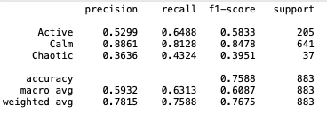

5. Discussion
The results demonstrate that deep convolutional architectures such as ResNet can effectively learn spatial–spectral patterns from Wi-Fi-derived range–Doppler maps. However, the model tends to overfit due to data imbalance and limited sample diversity. Future improvements may include:
- Temporal modeling using 3D CNNs or LSTM networks;
- Regularization (dropout, batch normalization tuning);
- Data augmentation through simulation or mixing of RD maps;
- Incorporating domain knowledge (e.g., Doppler distribution priors).

